Batch: A2 Roll No.: 16010122034
Experiment / assignment / tutorial No. 9

Grade: AA / AB / BB / BC / CC / CD /DD

Signature of the Staff In-charge with date

TITLE :Java Packages

AIM: Create a Package Engineering which has two classes as Student and Marks. Accept (n) student details like roll_no, Subject_name, Student_name,calculate total marks in the class Student Write display () method to display details and sort () method to sort the students records as per increasing order of the total marks. The function sort must be statically defined to invoke it without referring to any object. Both the functions are written in the Marks class.
Create a main class which will use a package to display all the records of the student in the increasing order of their total marks.
_____________________________________________________________________
Expected OUTCOME of Experiment:

CO4: Explore the interface, exceptions, multithreading, packages.

Books/ Journals/ Websites referred:

1. Ralph Bravaco , Shai Simoson , “Java Programming From the Group Up” Tata McGraw-Hill.

2.Grady Booch, Object Oriented Analysis and Design .
_____________________________________________________________________
Pre Lab/ Prior Concepts:

Java Packages:
A package in Java is a group of similar types of classes, interfaces, and sub-packages. They can be categorized into two categories, the built-in package ( java, lang, util, awt, javax, swing, net, io, sql et), and user-defined package.

They are used for the following tasks –
- To prevent the naming conflicts which can occur between the classes.
- Make the searching and locating of classes or enumerations or annotations much easier.
- Provide access control to the classes.
- Used for data encapsulation.

Advantages of Java Package:
- A Java package is mainly used for the categorization of classes and interfaces so that we can maintain them easily.
- They always provide access protection
- Used to bundle classes and interfaces.
- With the help of packages, we can reuse the existing code
- By using the package, we can easily locate the classes related to it.
- Also, remove the naming collision.

Built-in Packages in Java
Built-in is a part of Java API and it offers a variety of packages are –

lang – Automatically imported and it contains language support classes.
io – Contains classes for input and output operations.
util – Contains utility classes for implementing data structures.
applet – This package contains classes that create applets.
awt – Contain classes that implement compounds for GUI.
net – This package contains classes that support networking operations.

User-defined Packages in Java
- package First;

- public class MyClass
- {
- public void getNames(String name)
- {
- System.out.println(name);
- }

- }

- package First;
- import First.MyClass;
- public class MyClass1 {
- public static void main(String args[])
- {
- // Initializing the String variable with a value
- String name = "Welcome";
- // Creating an instance of class MyClass in the package.
- MyClass obj = new MyClass();
- obj.getNames(name);
- }
- }

.
Class Diagram:
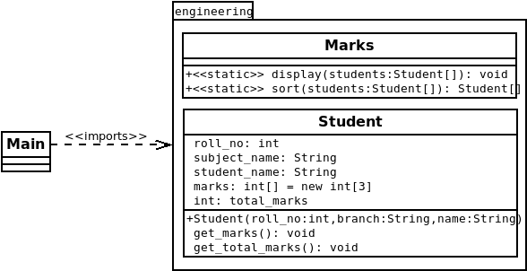

Algorithm:

Step 1: Start
Step 2: Input the number of records the user wishes to add.
Step 3: Create an array of Student objects of the same size as the number of records the user wishes to input
Step 4: Input the details of each student (roll number, name, branch and marks for 3 subjects) and make objects with each student’s inputted data.
Step 5: Display the data inputted by the user along with the total marks of each student
Step 6: Sort the data inputted by the user according to the total marks of the students
Step 7: Display sorted array of student records.
Step 8: End

Implementation details:
Classes in “engineering” Package:
- Marks:
package engineering;
public class Marks{
public static void display(Student[] students){
for (Student student : students){ System.out.println("##########################################");
System.out.println("Roll Number: " + student.roll_no);
System.out.println("Student name: " + student.student_name);
System.out.println("Branch: " + student.subject_name);
System.out.println("Marks in Subject 1: " + student.marks[0]);
System.out.println("Marks in Subject 2: " + student.marks[1]);
System.out.println("Marks in Subject 3: " + student.marks[2]);
System.out.println("Total Marks: " + student.total_marks);
}
}
public static Student[] sort(Student[] students){
int length = students.length;
for(int i = 0; i < (length - 1); i++){
int min = i;
for(int j = (i + 1); j < length; j++){
if(students[min].total_marks > students[j].total_marks)
j = min;
}
if(min != i){
Student temp = students[i];
students[i] = students[min];
students[min] = temp;
}
}
return students;
}
}
- Student:
package engineering;
import java.util.Scanner;
public class Student{
int roll_no;
String subject_name;
String student_name;
int[] marks = new int[3];
int total_marks;
public Student(int roll_no, String branch, String name){
this.roll_no = roll_no;
subject_name = branch;
student_name = name;
this.get_marks();
this.get_total_marks();
}
void get_marks(){
Scanner scan = new Scanner(System.in);
System.out.println("Enter Marks in Subject 1: ");
marks[0] = scan.nextInt();
System.out.println("Enter Marks in Subject 2: ");
marks[1] = scan.nextInt();
System.out.println("Enter Marks in Subject 3: ");
marks[2] = scan.nextInt();
}
void get_total_marks(){
for(int i = 0; i < 3; i++){
total_marks += marks[i];
}
}
}
Main Class outside package::
import engineering.*;
import java.util.Scanner;
public class Main{
public static void main(String[] args){
Scanner sc = new Scanner(System.in);
System.out.println("Enter number of records: ");
int num = sc.nextInt();
Student[] stud_list = new Student[num];
for (int i = 0; i < num; i++){
System.out.println("Enter Roll Number of the Student: ");
int roll_no = sc.nextInt();
System.out.println("Enter Branch of the Student: ");
String branch = sc.next();
System.out.println("Enter Name of the Student: ");
String name = sc.next();
stud_list[i] = new Student(roll_no, branch, name);
}
Marks.display(stud_list);
stud_list = Marks.sort(stud_list);
System.out.println("\n\nSorted list of students according to their total marks: ");
Marks.display(stud_list);
}
}
Output:
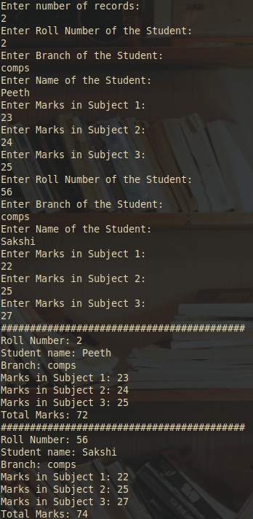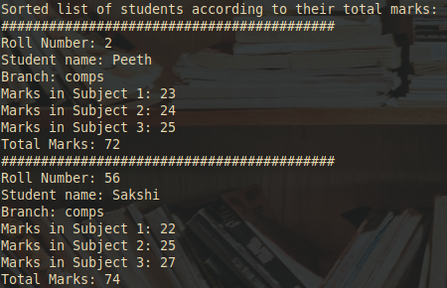
Conclusion: This experiment teaches us how to make java packages and utilize them in other java files.
Date: __________ Signature of faculty in-charge

Post Lab Descriptive Questions

Q.1 What are Java Packages? What's the significance of packages?
Package in Java is a mechanism to encapsulate a group of classes, sub packages and interfaces. Packages are significant for the following reasons:
- Preventing naming conflicts. For example there can be two classes with name Employee in two packages, college.staff.cse.Employee and college.staff.ee.Employee
- Making searching/locating and usage of classes, interfaces, enumerations and annotations easier
- Providing controlled access: protected and default have package level access control. A protected member is accessible by classes in the same package and its subclasses. A default member (without any access specifier) is accessible by classes in the same package only.
- Packages can be considered as data encapsulation (or data-hiding).

Q.2 Does Importing a package imports its sub-packages as well in Java?
No, importing a package does not import the sub-packages as well in Java.

